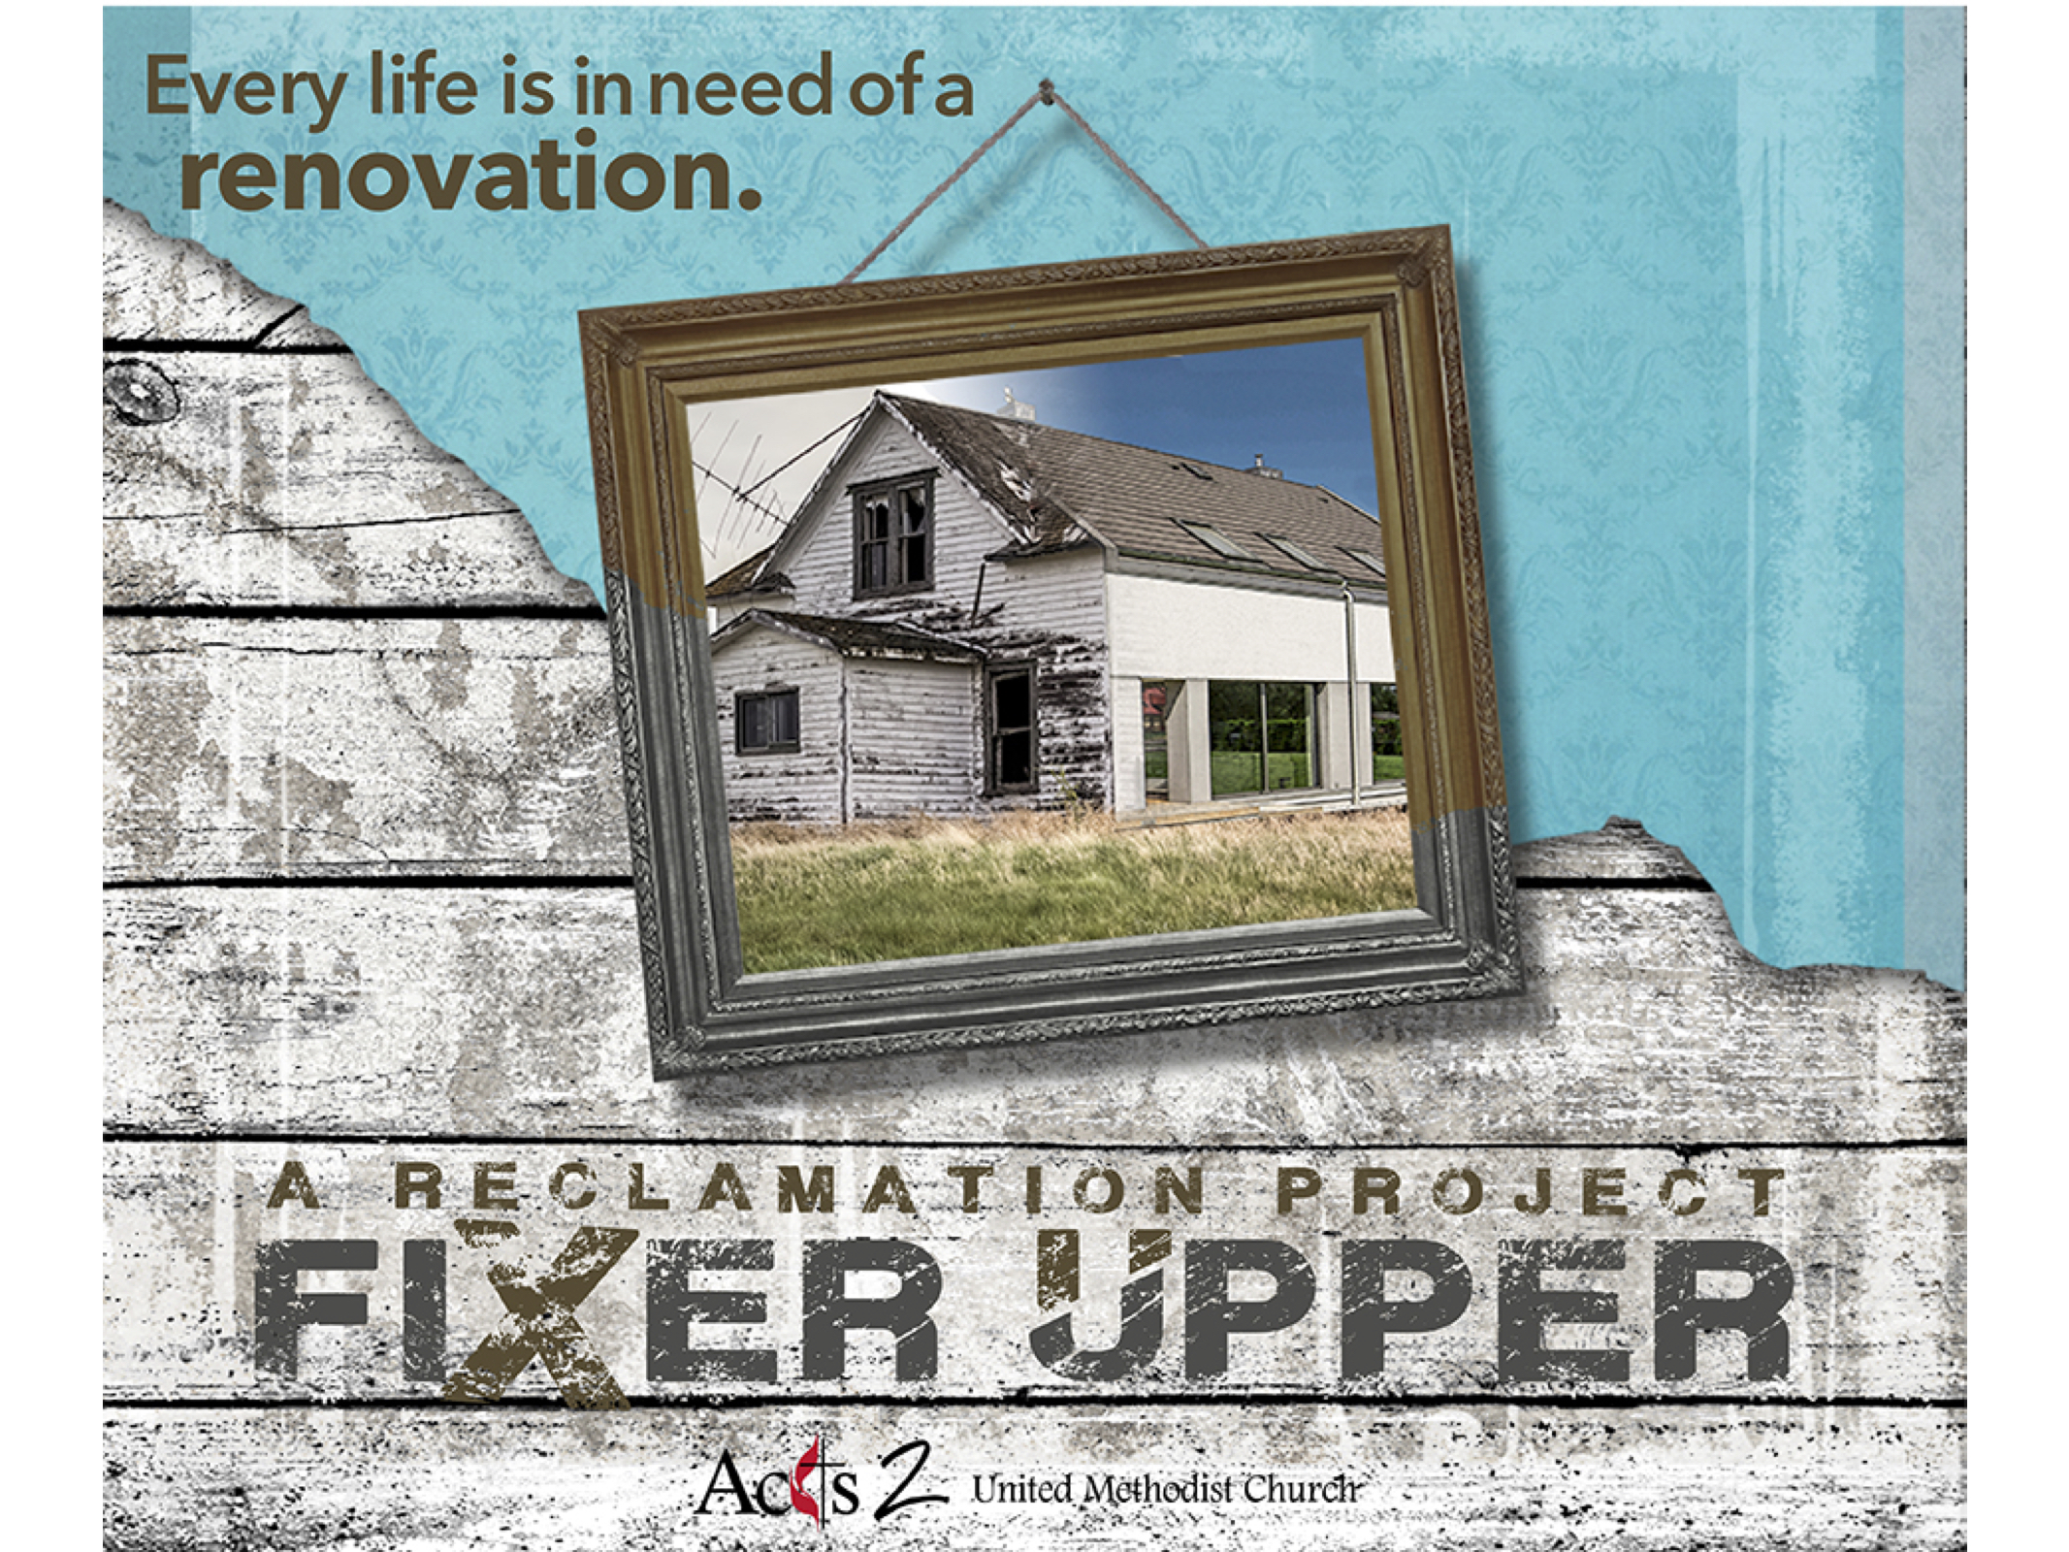

Jesus then began to teach his disciples. He taught them that the Son of Man must suffer many things. He taught them that the elders would not accept him. The chief priests and the teachers of the law would not accept him either. He must be killed and after three days rise again. He spoke clearly about this. Peter took Jesus to one side and began to scold him.
Jesus turned and looked at his disciples. He scolded Peter. “Get behind me, Satan!” he said. “You are not thinking about the things God cares about. Instead, you are thinking only about the things humans care about.”
Mark 8:31-33

Jesus then began to teach his disciples. He taught them that the Son of Man must suffer many things. He taught them that the elders would not accept him. The chief priests and the teachers of the law would not accept him either. He must be killed and after three days rise again. He spoke clearly about this. Peter took Jesus to one side and began to scold him.
Jesus turned and looked at his disciples. He scolded Peter. “Get behind me, Satan!” he said. “You are not thinking about the things God cares about. Instead, you are thinking only about the things humans care about.”
Mark 8:31-33

Fixer Upper
“Listen to the Carpenter”
February 23, 2018
Recap
-Building your dream home costs ____ as much and takes ____ as long.
-So does living your ____________ life.
-As we renovate our life, our temptation is to bypass the ___________.
Jesus’ Temptation
-Jesus asks the ________ who they think he is.
“Now when Jesus came into the district of Caesarea Philippi, he asked his disciples, ‘Who do people say that the _____ of _____ is?’”
Matthew 16:13-19
“Then he began to teach them that the Son of Man
must undergo great ___________…”
Mark 8:31-33
-Jesus is tempted by Peter to ___________ the suffering.
-Peter didn’t say anything that Jesus won’t say in the __________.
-Jesus shows the disciples who he is on the ___________.
Then Peter said to Jesus, “Rabbi, it is good for us to be here; let us make three __________, one for you, one for Moses, and one for Elijah.”
Mark 9:2-8
-Jesus is tempted ________ to bypass the suffering.
-Despite the temptation, Jesus led the way to the _______.
Our Temptation
We should never have the thought that our dreams of success are God’s purpose for us. In fact, His purpose may be exactly the opposite.
-Oswald Chambers
-The __________ temptation comes from those closest to us in the form of well-meaning friends and family.
“The tempter can make no more terrible attack than in the voice of those who love us and who think they seek only our good.”
-William Barclay
Action Steps
-What is God calling you to that requires ____________?
-How will you support someone else’s ____________?

Fixer Upper
“Listen to the Carpenter”
February 23, 2018
Recap
-Building your dream home costs ____ as much and takes ____ as long.
-So does living your ____________ life.
-As we renovate our life, our temptation is to bypass the ___________.
Jesus’ Temptation
-Jesus asks the ________ who they think he is.
“Now when Jesus came into the district of Caesarea Philippi, he asked his disciples, ‘Who do people say that the _____ of _____ is?’”
Matthew 16:13-19
“Then he began to teach them that the Son of Man
must undergo great ___________…”
Mark 8:31-33
-Jesus is tempted by Peter to ___________ the suffering.
-Peter didn’t say anything that Jesus won’t say in the __________.
-Jesus shows the disciples who he is on the ___________.
Then Peter said to Jesus, “Rabbi, it is good for us to be here; let us make three __________, one for you, one for Moses, and one for Elijah.”
Mark 9:2-8
-Jesus is tempted ________ to bypass the suffering.
-Despite the temptation, Jesus led the way to the _______.
Our Temptation
We should never have the thought that our dreams of success are God’s purpose for us. In fact, His purpose may be exactly the opposite.
-Oswald Chambers
-The __________ temptation comes from those closest to us in the form of well-meaning friends and family.
“The tempter can make no more terrible attack than in the voice of those who love us and who think they seek only our good.”
-William Barclay
Action Steps
-What is God calling you to that requires ____________?
-How will you support someone else’s ____________?

