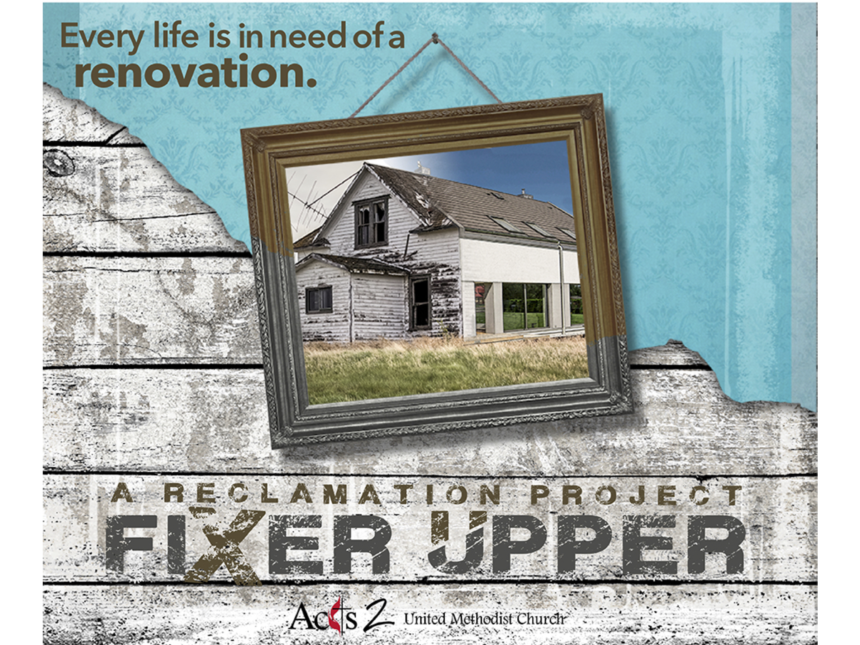

The next day the great crowd that had come to the festival heard that Jesus was coming to Jerusalem. ¹³ So they took branches of palm trees and went out to meet him, shouting,
“Hosanna!
Blessed is the one who comes in the name of the Lord—
the King of Israel!”

John 12:12-13

The next day the great crowd that had come to the festival heard that Jesus was coming to Jerusalem. ¹³ So they took branches of palm trees and went out to meet him, shouting,
“Hosanna!
Blessed is the one who comes in the name of the Lord—
the King of Israel!”

John 12:12-13

“The Reveal”
March 25, 2018

The Remodel Process: 1. A transformed life is available to you.
2. A transformed life requires suffering, rejection, and death.
3. A transformed life takes us outside the walls of the church.
4. Life in the unending presence of God is offered to everyone.
5. God will honor and reward anyone who serves Jesus.

The Context: Jesus arrived in Jerusalem for Passover.
__________ rode in from the east on a donkey from the Mt. of Olives.
_______________ rode in from the west, from Caesarea with chariots.
__________ Antipas rode into Jerusalem from the north, with guards.

The Problems: The ___________. John 11:43-45
The religious leaders ____________ of Rome. John 11:46-48, 53
Jesus’ friends were in real _______________. John 12:9-11
There was/is confusion concerning what kind of __________ Jesus is.

My Jesus vs. Savior of the World: The Problem of Psalm 118:26
“Blessed is the one who comes in the name of the Lord.” John 12:13
A song of _____________ for a returning king going to the Temple.
The crowd wrongly greeted Jesus as their _______________ hero.

The Reveal: Jesus’ Choice and Our Choice. John 11:54-57
Will we reveal who we really are in Christ knowing full-well we will be misunderstood by many and persecuted by some?
When Jesus sat on the donkey, it was a _________-sentence. 12:14-15
You can be humble and public at the __________ time. Zechariah 9:9
You are a child of God. Your playing small does not serve the world…We were born to make manifest the glory of God that is within us.
--Marianne Williamson

What Did Jesus Do? John 13:1-5
Jesus washed ____________ feet on the last night of His life!

What are We to Do? John 13:12-17
We are a public profession of Jesus everyday,
not just this day. @MarkFosterA2

Action Step: Serve someone who is _____________ to love.
“The Reveal”
March 25, 2018

The Remodel Process: 1. A transformed life is available to you.
2. A transformed life requires suffering, rejection, and death.
3. A transformed life takes us outside the walls of the church.
4. Life in the unending presence of God is offered to everyone.
5. God will honor and reward anyone who serves Jesus.

The Context: Jesus arrived in Jerusalem for Passover.
__________ rode in from the east on a donkey from the Mt. of Olives.
_______________ rode in from the west, from Caesarea with chariots.
__________ Antipas rode into Jerusalem from the north, with guards.

The Problems: The ___________. John 11:43-45
The religious leaders ____________ of Rome. John 11:46-48, 53
Jesus’ friends were in real _______________. John 12:9-11
There was/is confusion concerning what kind of __________ Jesus is.

My Jesus vs. Savior of the World: The Problem of Psalm 118:26
“Blessed is the one who comes in the name of the Lord.” John 12:13
A song of _____________ for a returning king going to the Temple.
The crowd wrongly greeted Jesus as their _______________ hero.

The Reveal: Jesus’ Choice and Our Choice. John 11:54-57
Will we reveal who we really are in Christ knowing full-well we will be misunderstood by many and persecuted by some?
When Jesus sat on the donkey, it was a _________-sentence. 12:14-15
You can be humble and public at the __________ time. Zechariah 9:9
You are a child of God. Your playing small does not serve the world…We were born to make manifest the glory of God that is within us.
--Marianne Williamson

What Did Jesus Do? John 13:1-5
Jesus washed ____________ feet on the last night of His life!

What are We to Do? John 13:12-17
We are a public profession of Jesus everyday,
not just this day. @MarkFosterA2

Action Step: Serve someone who is _____________ to love.

