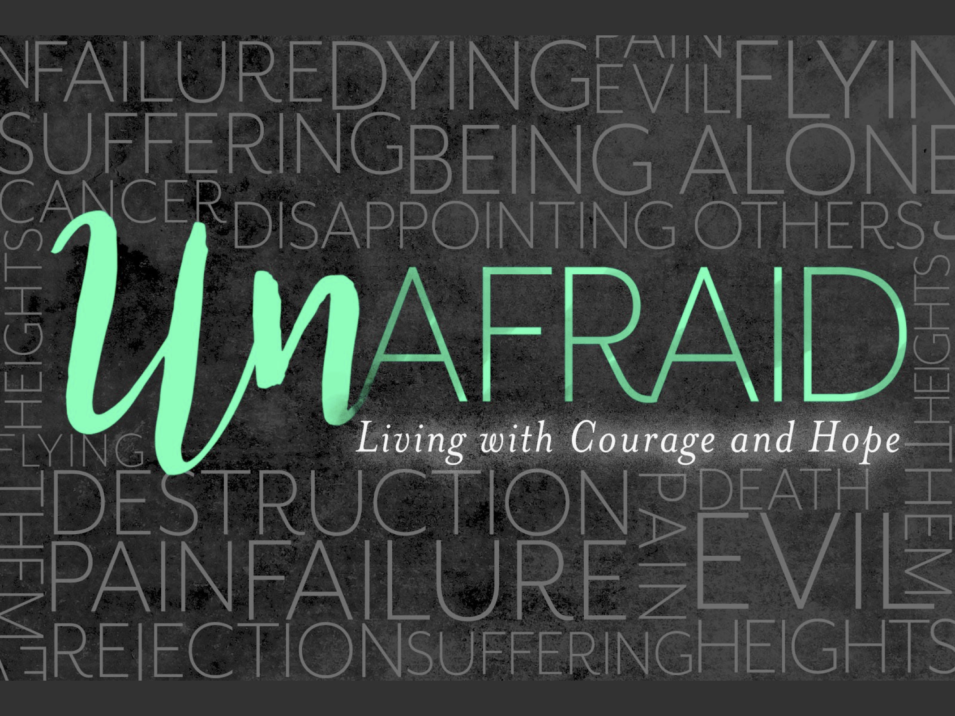

But on the first day of the week, at early dawn, they came to the tomb, taking the spices that they had prepared. They found the stone rolled away from the tomb, but when they went in, they did not find the body. While they were perplexed about this, suddenly two men in dazzling clothes stood beside them. The women were terrified and bowed their faces to the ground, but the men said to them, “Why do you look for the living among the dead? He is not here, but has risen.

Luke 24:1-5
NRSV

But on the first day of the week, at early dawn, they came to the tomb, taking the spices that they had prepared. They found the stone rolled away from the tomb, but when they went in, they did not find the body. While they were perplexed about this, suddenly two men in dazzling clothes stood beside them. The women were terrified and bowed their faces to the ground, but the men said to them, “Why do you look for the living among the dead? He is not here, but has risen.

Luke 24:1-5
NRSV

“Overcoming Fear”
March 31, 2018
He is risen! He is risen indeed!
-The first reaction to the resurrection was ________.
-Fear is one of the _________ and most _________ human emotions.
-____________ – Part of the brain that protects you in two main ways.
-__________ to & ____________ something from happening.
-We have ____________ imaginations of what could happen.
-What are you fearing today?
_________, Direction of _____, _________, _________.
The Problem of FEAR – F______ E______ A__________ R______.
-Jesus said that he would ______ & _______ again on the third day.
“Jesus began to show his disciples that he must…undergo great suffering…and scribes and be killed, and on the third day be _______.”
Matthew 16:21-23
1. Fear can cause us to _________ what we had previously known.
“The women were _________…but the men said to them, ‘Why do you look for the living among the dead? He is not here, but has risen.’”
Luke 24:1-5
2. Fear can make us ___________.
“The doors…were locked for ______ of the Jews, Jesus came and stood among them and said, ‘Peace be with you.’”
John 20:19-20
3. Fear can cause us to “_____________” our current situation.
The Answer to FEAR-Face your fears with ________.
Examine your assumptions in light of _________.
Attack your anxieties with ________.
Release your cares to the ___________.
“Death is swallowed up in victory. O death, where is thy sting?
O grave, where is thy victory?”
1 Corinthians 15:51-58
“Courage is fear that has said its prayers.”
-Dorothy Bernard
Action Steps
__________ yourself up to the presence of God through:
-___________, ___________,
& __________ your struggles with someone safe.

“Overcoming Fear”
March 31, 2018
He is risen! He is risen indeed!
-The first reaction to the resurrection was ________.
-Fear is one of the _________ and most _________ human emotions.
-____________ – Part of the brain that protects you in two main ways.
-__________ to & ____________ something from happening.
-We have ____________ imaginations of what could happen.
-What are you fearing today?
_________, Direction of _____, _________, _________.
The Problem of FEAR – F______ E______ A__________ R______.
-Jesus said that he would ______ & _______ again on the third day.
“Jesus began to show his disciples that he must…undergo great suffering…and scribes and be killed, and on the third day be _______.”
Matthew 16:21-23
1. Fear can cause us to _________ what we had previously known.
“The women were _________…but the men said to them, ‘Why do you look for the living among the dead? He is not here, but has risen.’”
Luke 24:1-5
2. Fear can make us ___________.
“The doors…were locked for ______ of the Jews, Jesus came and stood among them and said, ‘Peace be with you.’”
John 20:19-20
3. Fear can cause us to “_____________” our current situation.
The Answer to FEAR-Face your fears with ________.
Examine your assumptions in light of _________.
Attack your anxieties with ________.
Release your cares to the ___________.
“Death is swallowed up in victory. O death, where is thy sting?
O grave, where is thy victory?”
1 Corinthians 15:51-58
“Courage is fear that has said its prayers.”
-Dorothy Bernard
Action Steps
__________ yourself up to the presence of God through:
-___________, ___________,
& __________ your struggles with someone safe.

