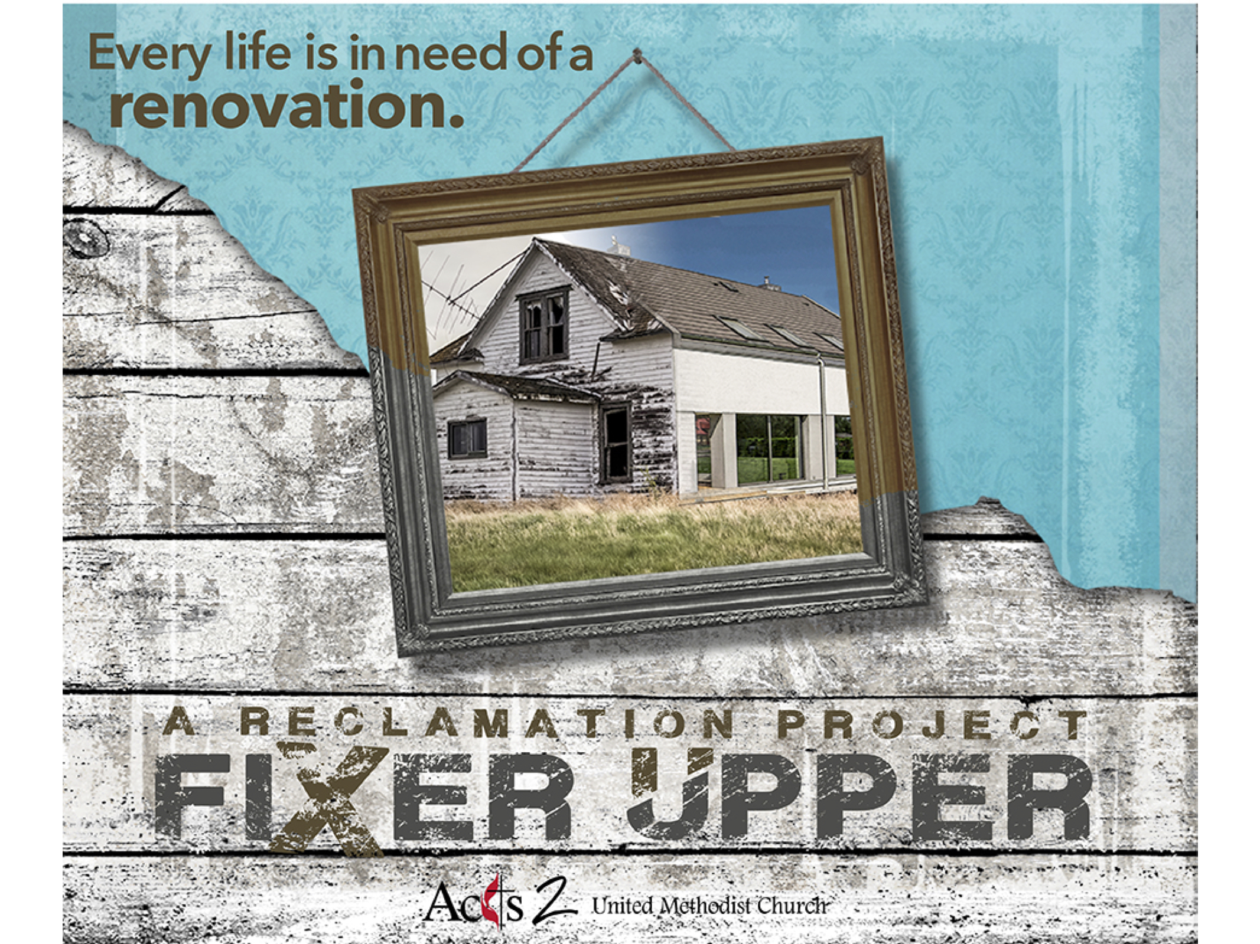

“Listen carefully: Unless a grain of wheat is buried in the ground, dead to the world, it is never any more than a grain of wheat. But if it is buried, it sprouts and reproduces itself many times over. In the same way, anyone who holds on to life just as it is destroys that life. But if you let it go, reckless in your love, you’ll have it forever, real and eternal.”

John 12:24-25
The Message

“Listen carefully: Unless a grain of wheat is buried in the ground, dead to the world, it is never any more than a grain of wheat. But if it is buried, it sprouts and reproduces itself many times over. In the same way, anyone who holds on to life just as it is destroys that life. But if you let it go, reckless in your love, you’ll have it forever, real and eternal.”

John 12:24-25
The Message

Fixer Upper
“In Over Your Head”
March 16, 2018
Recap
-Your renovated life costs ______ as much and takes ______ as long.
-Compare a previously held belief/action to __________.
-__________ it if it doesn’t measure up.
In Over Your Head
-Hopefully we will come to a point where we realize our own _________.
We can’t know where God begins if we don’t know where we end.
@onechurchacts2
“Now among those who went up to worship at
the festival were some _________…”
John 12:20-22
-Greeks coming to Jesus was a sign of ________ becoming _________.
-Who did they go to? _________ and _________ who were Greek.
-What did they say? “We wish to ______ Jesus.”
-Andrew & Philip were the first to invite others to “Come and ______.”
“Nathanael said to him, ‘Can anything good come out of Nazareth?’ _______ said to him, ‘Come and see.’”
John 1:44-46
-When others wanted to come to Jesus they found people ______ them.
“Fish in ponds you _________.” -Rev. Jim Ozier
"…Unless a grain of wheat falls into the earth and ______,
it remains just a single grain; but if it dies, it bears much fruit.”
John 12:23-24
-Finding your own limits is the precursor to bearing _________.
If you haven’t failed you aren’t trying hard enough! @onechurchacts2
“Those who love their _______ lose it, and those who hate their ______ in this world will keep it for eternal life.”
John 12:25-26
Action Steps
-Lose your life = Take _______ and ______ in proportion to your income.
-You cannot do it ________.
“Now my soul is troubled. And what should I say—‘Father, _______ me from this hour’? No, it is for this reason that I have come to this hour.”
John 12:27-28

Fixer Upper
“In Over Your Head”
March 16, 2018
Recap
-Your renovated life costs ______ as much and takes ______ as long.
-Compare a previously held belief/action to __________.
-__________ it if it doesn’t measure up.
In Over Your Head
-Hopefully we will come to a point where we realize our own _________.
We can’t know where God begins if we don’t know where we end.
@onechurchacts2
“Now among those who went up to worship at
the festival were some _________…”
John 12:20-22
-Greeks coming to Jesus was a sign of ________ becoming _________.
-Who did they go to? _________ and _________ who were Greek.
-What did they say? “We wish to ______ Jesus.”
-Andrew & Philip were the first to invite others to “Come and ______.”
“Nathanael said to him, ‘Can anything good come out of Nazareth?’ _______ said to him, ‘Come and see.’”
John 1:44-46
-When others wanted to come to Jesus they found people ______ them.
“Fish in ponds you _________.” -Rev. Jim Ozier
"…Unless a grain of wheat falls into the earth and ______,
it remains just a single grain; but if it dies, it bears much fruit.”
John 12:23-24
-Finding your own limits is the precursor to bearing _________.
If you haven’t failed you aren’t trying hard enough! @onechurchacts2
“Those who love their _______ lose it, and those who hate their ______ in this world will keep it for eternal life.”
John 12:25-26
Action Steps
-Lose your life = Take _______ and ______ in proportion to your income.
-You cannot do it ________.
“Now my soul is troubled. And what should I say—‘Father, _______ me from this hour’? No, it is for this reason that I have come to this hour.”
John 12:27-28

