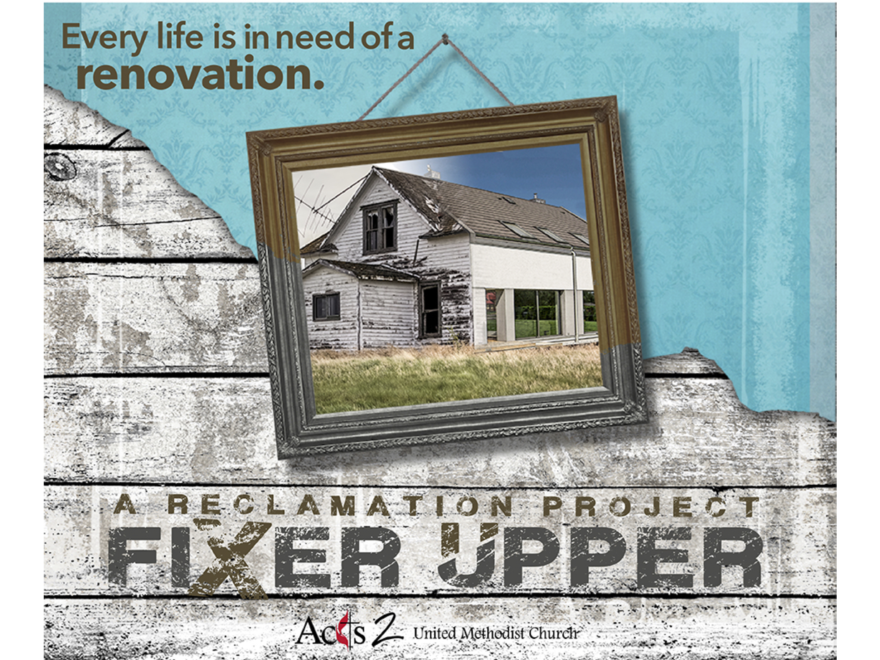

In those days Jesus came from Nazareth of Galilee and was baptized by John in the Jordan. And just as he was coming up out of the water, he saw the heavens torn apart and the Spirit descending like a dove on him. And a voice came from heaven, ‘You are my Son, the Beloved;
with you I am well pleased.’
And the Spirit immediately drove him out into the wilderness.

Mark 1:9-12

In those days Jesus came from Nazareth of Galilee and was baptized by John in the Jordan. And just as he was coming up out of the water, he saw the heavens torn apart and the Spirit descending like a dove on him. And a voice came from heaven, ‘You are my Son, the Beloved;
with you I am well pleased.’
And the Spirit immediately drove him out into the wilderness.

Mark 1:9-12

“Build Your Dream Home”
Fixer Upper Sermon Series
February 18, 2018

__________ life is in need of a renovation.
_______ is the time we are invited to make a radical return to God.
“Dream Home” is a metaphor for a _______________ life.
 “A life of victory over sin and circumstance
is accessible to all.”–Dallas Willard

I. What We Need to Know to Get Started
It is not a _______ fix. You won’t be Super Christian by Tuesday.
It is going to _______ more than you want.
It takes ____________ than you think.
You _________ do it with God’s help.

II. Jesus Shows Us How to be Transformed
1. Jesus faced a moment of _________ after 30 years in Nazareth.
He left his home and went to John at the river (Mark 1:9).
Step 1 of AA: We admitted we were powerless over our addiction – that our lives had become unmanageable.
2. Jesus’ baptism was also a moment of _______________ (10).
3. Jesus’ decision led to his _______________ as God’s Son (11).
Courage starts with showing up and letting ourselves be seen.
– Brene Brown
III. Testing the Hero
It was the ________ who thrust Jesus out into the wilderness.
___________ are not sent to make us fall or fail (Matthew 4:1-4).
Jesus refused to allow His _________ to be influenced by concern
for his __________ or pleasure.
Jesus answers the temptation with ______________ (5-7).
There are no short cuts to greatness. Sacrifice is required (8-10).

Action Steps: Be __________. Get _____________!
Leave the ____________ to God. It’s His house. (Matthew 4:11)
“Build Your Dream Home”
Fixer Upper Sermon Series
February 18, 2018

__________ life is in need of a renovation.
_______ is the time we are invited to make a radical return to God.
“Dream Home” is a metaphor for a _______________ life.
“A life of victory over sin and circumstance
is accessible to all.”–Dallas Willard

I. What We Need to Know to Get Started
It is not a _______ fix. You won’t be Super Christian by Tuesday.
It is going to _______ more than you want.
It takes ____________ than you think.
You _________ do it with God’s help.

II. Jesus Shows Us How to be Transformed
1. Jesus faced a moment of _________ after 30 years in Nazareth.
He left his home and went to John at the river (Mark 1:9).
Step 1 of AA: We admitted we were powerless over our addiction – that our lives had become unmanageable.
2. Jesus’ baptism was also a moment of _______________ (10).
3. Jesus’ decision led to his _______________ as God’s Son (11).
Courage starts with showing up and letting ourselves be seen.
– Brene Brown
III. Testing the Hero
It was the ________ who thrust Jesus out into the wilderness.
___________ are not sent to make us fall or fail (Matthew 4:1-4).
Jesus refused to allow His _________ to be influenced by concern
for his __________ or pleasure.
Jesus answers the temptation with ______________ (5-7).
There are no short cuts to greatness. Sacrifice is required (8-10).

Action Steps: Be __________. Get _____________!
Leave the ____________ to God. It’s His house. (Matthew 4:11)

